**TUTORIAL 3**

1. Briefly describe TWO (2) weaknesses, TWO (2) strengths and TWO (2) threats when performing SWOT analysis on UTAR in providing education in Malaysia

W1: Lack of facilities

W2: Chinese-speaking environment

S1 : Tuition fee is affordable

S2: Good ranking

T1: Other affordable private universities.

T2: Online learning portal

1. A new government law requires an organization to report data in a new way. Under which category would a new IS project to provide this data fall?
2. problem b) opportunity c) directive d) regulation
3. If estimates for total discounted benefits for a project are $120,000 and total discounted costs are $100,000, what is the estimated return on investment (ROI)?
4. $20,000 b) $120,000 c) 20 percent d) 120 percent
5. Which of the following is TRUE about payback period?
6. It is always positive number b) It is expressed in term of percentage

c) It is the amount of time it takes to spend the invested money

d) It is the amount of time it takes to recoup the invested money

1. Develop a weighted scoring model with 5 criteria when you are looking for a “good” roommate. Put in THREE (3) candidates with random scores and determine the one that you choose to be your roommate.

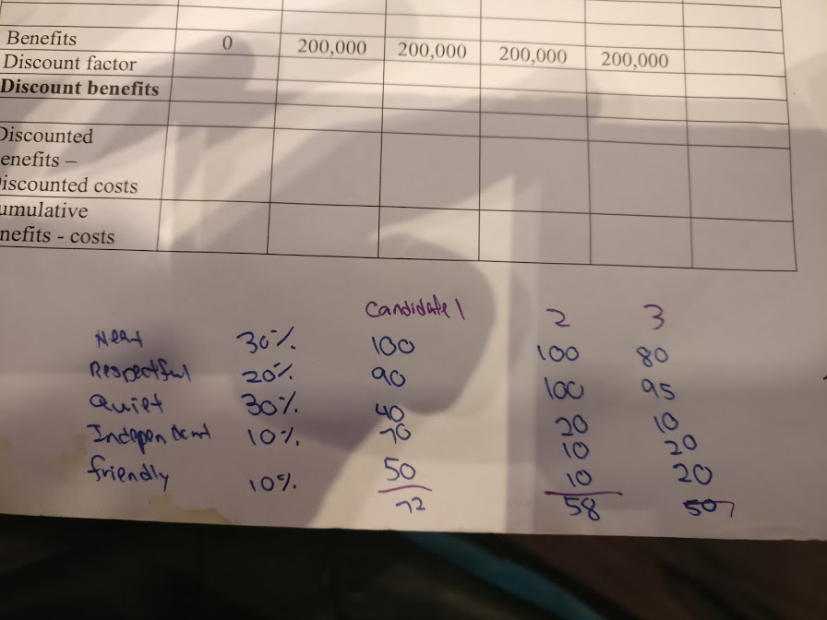

1. Calculate NPV, ROI, and payback for the information below.

|  |  |  |  |  |  |  |
| --- | --- | --- | --- | --- | --- | --- |
| **Discount rate** | **8%** |  |  |  |  |  |
| Assume the project is completed in Year 0 | | | | | | |
|  |  |  |  |  |  |  |
|  | **Year 0** | **Year 1** | **Year 2** | **Year 3** | **Year 4** | **Total** |
| Costs | 140,000 | 50,000 | 50,000 | 50,000 | 50,000 |  |
| Discount factor | 1 | 0.93 | 0.86 | 0.79 | 0.74 |  |
| **Discount costs** | **140,000** | **46,500** | **43,000** | **39,500** | **37,000** | **306,000** |
|  |  |  |  |  |  |  |
| Benefits | 0 | 200,000 | 200,000 | 200,000 | 200,000 |  |
| Discount factor | 1 | 0.93 | 0.86 | 0.79 | 0.74 |  |
| **Discount benefits** | **0** | **186,000** | **172,000** | **158,000** | **148,000** | **664,000** |
|  |  |  |  |  |  |  |
| Discounted benefits – Discounted costs | (140,000) | 139,500 | 129,000 | 118,500 | 111,000 |  |
| Cumulative benefits - costs | (140,000) | (500) | 128,500 | 247,000 | 358,000 |  |

ROI: (664,000-306,000)/306,000=1.17

Payback period: 2 years.